NHS NORTH CENTRAL LONDON INTEGRATED CARE BOARD
FUNCTIONS AND DECISIONS MAP

ICB Governance Structure
The ICB’s proposed governance structure is as follows:

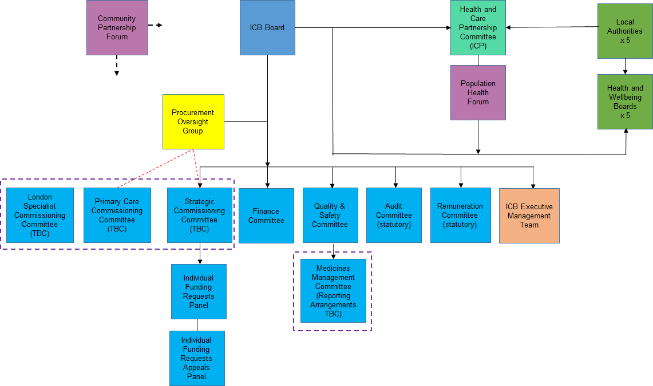
Key Functions

A high level overview of the governance structure is set out below:

ICB Board
The ICB Board has overall accountability and responsibility for the discharge of the ICB’s functions (including all statutory requirements of the ICB). The ICB Board will take an active role in decision making and oversight, meeting regularly to enact business.

The ICB Board sets the culture of the organisation, taking a supportive approach to subsidiarity and working with Borough Partnerships to develop our collective approach and learn what works best in different settings in order to deliver improved health outcomes for NCL residents and patients.

Strategic Commissioning Committee (TBC)
The need for this committee is still to be determined - subject to the level of commissioning decision-making through the ICB Board and via delegated arrangements through other committees or reserved through the ICB Executive Management Team.

Finance Committee
This provides oversight and assurance around ICB and system finances, ICB budgets and associated expenditure and the delivery of strategic financial plans and efficiency programmes.

Quality and Safety Committee
This provides oversight and assurance for quality, safety and performance. It also develops the ICS’s strategic approach to quality, safety and performance and ensure it is delivered.

Audit Committee
The Audit Committee is a statutory requirement – and critically reviews and reports to the ICB Board on the relevance and robustness of the governance and assurance processes on which the Board relies. This remit of the Audit Committee includes reviewing the effectiveness of governance, risk management, internal controls, finance and counter fraud systems.
Remuneration Committee
The Remuneration Committee is a statutory requirement – and approves board, clinical lead and executive level pay (outside of pay arrangements set at a national level – in accordance with the national model constitution for ICB statutory bodies). It also sets the ICB’s pay policy.

ICB Executive Management Team
Exercises decision making for those functions delegated to the ICB Executive Management Team as a whole. Ensures operational oversight of the ICB and inputs into strategic decision making.

Procurement Oversight Group
This group provides oversight and assurance to the ICB Board that key procurements undertaken by the ICB (including under the Provider Selection Regime) follow the regime correctly, are transparent, conflicts of interest are appropriately managed and that the process is properly evidenced.

Individual Funding Requests (IFR) Panel & Appeals Panel
A statutory requirement transferred from the CCG, the IFR Panel will make decisions on behalf of the ICB Board on individual funding requests. As it makes commissioning decisions it is proposed to report into the Population Health Committee.

The Appeals Panel will sit in the event of challenge following an IFR decision taken through the IFR Panel.

Medicines Management Committee
This provides oversight and assurance for medicines. It develops the ICS’s strategic approach to medicines and ensures that the ICS’s recommendations, advice and guidance on medicines is appropriate. It is proposed that the Medicines Management Committee is a sub-committee of the ICB Quality & Safety Committee.

London Specialist Commissioning Committee (TBC)
This is expected to be a joint committee between NHS England and other London ICBs to jointly commission specialist services across London. However, we are awaiting further guidance on this.

Primary Care Commissioning Committee (TBC)
It is unknown at this stage whether NHS England will require ICBs to hold a bespoke primary care commissioning committee to exercise its delegated primary care commissioning functions. If the ICB is required by NHS England to hold a bespoke committee then this committee will be responsible for carrying out the function relating to the strategic development of primary medical services and associated commissioning arrangements.

Forums for Partnership Working with other Organisations

Health and Care Partnership Committee
This joint committee is the Integrated Care Partnership committee. It is a joint committee between the ICB and the Local Authorities in North Central London. Its role is to develop the Integrated Care Strategy for North Central London and to facilitate joint action to improve health and care services and to influence the wider determinants of health and broader social and economic development.

Community Partnership Forum
This forum ensures effective community and citizen participation in the work of the wider Integrated Care System. It includes important system partners such as Healthwatch and other community groups.

Population Health Forum
This forum is responsible for developing the ICS’s approach to population health and overseeing its delivery, addressing health inequalities and inequity of access and outcomes. The forum is a key link between Borough Partnerships and their activities and NCL wide strategies and priorities and will lead and support the development of relationships between organisations in the ICS partnership to support the delivery of population health improvements. The forum will understand and champion the needs of our local population (and population cohorts) with a focus on reducing inequalities and steer and guide the ongoing evolution of the NCL Population Health Strategy.

Health and Wellbeing Boards
The Health and Wellbeing Boards are responsible for the Joint Strategic Needs Assessments and the development of the Joint Health and Wellbeing Strategies for each of their respective areas. These will form the foundation of the Integrated Care Strategy developed at the Health and Care Partnership Committee (i.e. the ICP).

